FOR IMMEDIATE RELEASE

PUR Adhesives Confirmed to Work With Silicone Rubber Sheets in Mass Production

Opening Doors to Silicone Rubber Usage With Existing Hot-Melt, Cold and Hybrid Adhesives
Hsinchu, Taiwan, December 29 2020 - Experienced silicone product maker, General Silicones (GS), confirms the compatibility of its Compo-SiL® silicone rubber sheets with standard PUR adhesives. Many unique silicone properties, such as UV stability, usability in high and low temperature, electric discharge safety, make it an ideal material. But the extreme difficulty of bonding cured silicone to other surfaces prevents silicone from broader use.

Achieving Reliable Silicone Rubber Bonding with PUR Adhesives
The low surface energy of silicone rubber makes the creation of "adhesives for silicone rubber" difficult. Compo-SiL® silicone rubber by GS solves this critical challenge for the adhesive industry. GS provides a thin modified layer of Polyurethane (PU) bonded to the silicone rubber. The PU layer allows the bonding reaction with the PUR adhesive.

PUR as adhesive/laminate for silicone bonding solutions for various Industries through Compo-SiL®
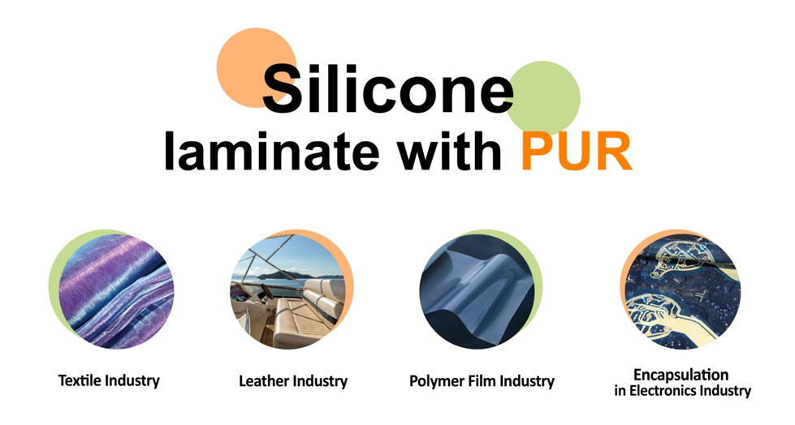

Compo-SiL® PUR Adhesion versus Traditional Silicone Bonding
Adhesives for silicone rubber are limited and are chosen depending on the products' functionality and application. Surface priming or various other costly treatments like plasma and corona approaches are still necessary.
Compo-SiL® overcomes this by bonding with well-known and popular Polyurethane Reactive Adhesives.

Bridging the Gap Between the Adhesive Industry and Silicone
Compo-SiL® technology bridges the gap between the adhesive industry and the silicone industry. It can be used for both soft-to-soft plastic adhesion and hard-and-soft plastic adhesion. For more information, please refer to PUR laminate/adhesive for silicone.
The use of Compo-SiL® silicone rubber is possible for any situation where PUR adhesives are applicable. Compo-SiL® is fined tuned to customer needs and applied in various scenarios where PUR adhesives act as laminate. A few example scenarios are:
- Compo-SiL® sheets work with existing PUR machines. It allows for roll-to-roll, solvent-free, and room temperature manufacturing processes.
- In the textile industry, Compo-SiL® allows for fabric lamination with silicone surface.
- The Polymer film industry can laminate thermoplastic and thermoset films with silicone as one surface using PUR adhesives.
- The electronics industry now has the option to bond Compo-SiL® encapsulated circuits with PUR adhesives.

Advantages of the Combination of PUR Adhesives with Compo-SiL®
PUR adhesives bond well with various materials and can do so in both low and high temperatures. They have permanent elasticity and flexibility. For high-strength and waterproof bonding, PUR adhesives are well suited. All these characteristics make PUR adhesives perfect for silicone adhesion and bonding use.
Compo-SiL® silicone rubber bonds to wood, metals, leather, cured epoxy, rubbers, glass, concrete, and many more materials using PUR adhesives.

Avoiding and Minimizing Plastic with Green Silicone
Customers demand to replace plastic and develop greener products. Combining the strengths of the PUR adhesive industry with Compo-SiL® silicone allows manufacturers to react to market demand. Using existing production lines, PUR adhesives, and Compo-SiL®, more sustainable products are achievable.
For more information, you can contact the GS sales team at compo-sil@gsweb.com.tw, or visit www.compo-sil.com
Compo-SiL®: Part of your life!

About General Silicones
General Silicones (GS) was founded in 1970 in Taipei, Taiwan, and is now represented worldwide – including Europe, China, Japan, and South-East Asian countries. GS is a major distributor of silicone materials and an active silicone products manufacturer with ISO 9001, IATF 16949, and ISO 14001 certifications. The company has manufacturing plants in Hsinchu, Taiwan; Wujiang, China; and Bac Giang, Vietnam. With decades of experience in this field, GS has the ability and capacity to provide a wide range of silicone products for many industries, including medical, automobile, consumer products, electronics, and IT. GS listed on Taiwan's Emerging Stock Market in 2011 (TPEx: 4730). For more information about GS, please visit www.generalsilicones.com. For more information on Compo-SiL®, please visit www.compo-sil.com

