GlacialTech invites media to attend TAITRONICS Taiwan 2008

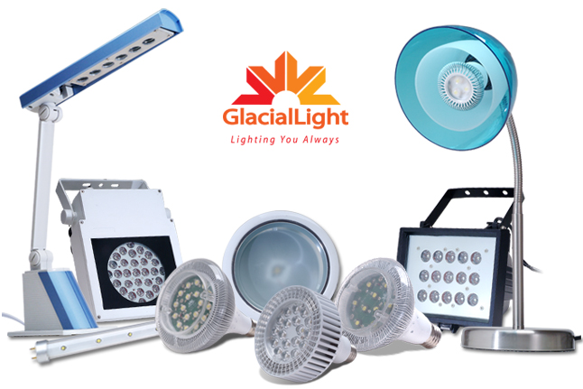
October 2008- GlacialTech Inc is proud to welcome all interested parties, from customers to media partners to attend their booth in the new TWTC NanGang Exhibition Complex during the TAITRONICS Taiwan show to be held in Taipei from 7th to 11th October, 2008. TAITRONICS 2008 is organized by TAITRA (Taiwan External Trade Development Council) and TEEMA (Taiwan Electronic Manufacturers’ Association).

The products on display in various categories of LED Lighting Solutions can be seen at booth numbers L0425 in the NanGang Exhibition Center. The focus of the booth display will be the introduction of many new models of LED lighting luminaries that are unique, and yet conform to traditional lighting structures. All the products on display are available as finished LED products under GlacialTech’s newly introduced sub brand called GlacialLight. Through a combination of their resources, GlacialTech has leveraged quality products under the GlacialLight brand with the introduction of their innovative Light Emitting Diode (LED) luminaries.
TYPE | Watts | Saving  Energy | life time  (hrs) | Improvement  (times)
LED-MR16 | 3.5 | 93% | 50,000 | 12
LED-PAR30 | 10.6 | 86% | 50,000 | 10
LED-PAR38 | 21.1 | 82% | 50,000 | 10
LED-BR30 | 10.6 | 86% | 50,000 | 10
LED-BR40 | 21.1 | 75% | 50,000 | 10
LED-T8 2 Feet | 11.7 | 42% | 50,000 | 5
LED-T8 4 Feet | 23.5 | 41% | 50,000 | 5

Wide product range under development
GlacialTech is developing a comprehensive range of products under the GlacialLight brand, stretching from street lighting solutions to all forms of industrial and architectural lighting. The products on offer and in development include serious product enhancements over the current range of competing products available on the market, such as MR16/ PAR30/ PAR38/ BR20/ BR30/ BR40/ T8 Tubes and Spotlights as well as an innovative and unique types of Torches and Bicycle lamps designed with multi-functionality as the key ingredients. These LED products on display will retain the customary shape and design of standard globes to allow easy replacement of legacy products. The product line is quite extensive and includes replacements for standard light bulbs and tubes for homes and offices.

Experienced electronics manufacturer
Some of GlacialLight products compared
To ensure the best performance and long life time of LED luminary products requires efficient and consistent cooling of the LED, with a durable high quality power supply. As experienced manufacturer of PC cooling and power supplies GlacialLight has leveraged the resources required to create quality LED lighting products combining the exemplary cooling capabilities with durable power unit designs to create optimal solutions for the most demanding of lighting products.

Advantages of LED compared to traditional lighting
LED lights offer the following advantages and benefits compared to traditional globes (Filament) and compact fluorescent Lamp (CFL) products, such as directional lighting, which is ideal for torches and spotlights. There are no starting problems in cold environments because LED’s are “Instant on” with no warm up time needed as seen in conventional CFL lighting. In addition, LED lighting solutions do not contain environmentally hazardous metals such as mercury or sodium and do not emit potentially harmful Ultraviolet radiation or Infrared radiation like Halogen lamps. Another benefit is the extremely long life cycle of around 30 000 hrs which lowers maintenance costs in the long term. The GlacialLight LED product range offers considerable power savings while extending long product life cycles under normal conditions. The advantages of LED lighting adding to the lowering of the world’s carbon footprint cannot be underestimated.

About GlacialLight
GlacialTech Inc., is a diversified provider of cooling, power supply, PC enclosure solutions for the consumer and industrial applications. Having established strong relationships with LED semiconductor Co.’s, thermal, SMPS and mechanism technology leaders worldwide, GlacialTech leverages world-class engineering, efficient manufacturing and highest-quality materials to provide high brightness, low power LED lighting solutions for indoor, outdoor and other customized applications under the GlacialLight brand. For more information visit www.glaciallight.com

PR Contact: GlacialTech Inc. TEL : +886 2 2244 1227 E-mail : PR@GlacialTech.com

