FOR IMMEDIATE RELEASE

Lancool Announces PC-K56N Mid Tower Chassis

Refined Cooling Design with Tool-less Features
15 February 2012, Keelung, Taiwan - Lancool, a manufacturer of mid to high-end computer chassis, has launched a new mid-tower PC case for the Dragon Lord Series – PC-K56N. Designed for ATX, Micro-ATX, and Mini-ITX motherboards, the PC-K56N includes many tool-less features as well as an efficient interior layout to keep your system cool.
The chassis' adjustable HDD rack supports up to three 3.5-inch HDDs as well as two 2.5-inch HDDs or SSDs which can be set to face forward or backward. Installation is simplified for users with the included thumbscrews, and the rubber suspension keeps vibration to a minimum.
The front 140mm and rear 120mm fans facilitate the flowing of cool air throughout the system. The side panel gives more cooling options with space for two additional 140mm or 120mm fans. For users who want more, the PC-K56N supports a liquid cooling system with two holes for water tubes protected by rubber covers.
As to be expected from Lancool, the PC-K56N features numerous tool-less characteristics from effortless optical drive mounting to an easy-to-remove detachable front panel. Additionally, the 8 vented PCI brackets require no extra equipment when installing thanks to the thumbscrews.
Cable management is a breeze. Expertly placed and designed cable clamps keeps those in-the-way wires neat and secure. With the cables out-of-the-way, cool air flows unobstructed throughout the Lancool PC-K56N's interior keeping hardware at its optimum operating temperatures.

Specifications:
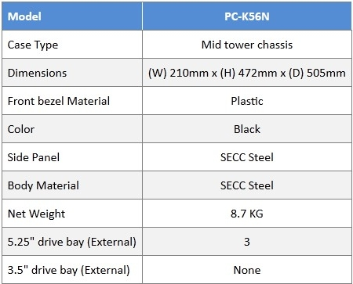
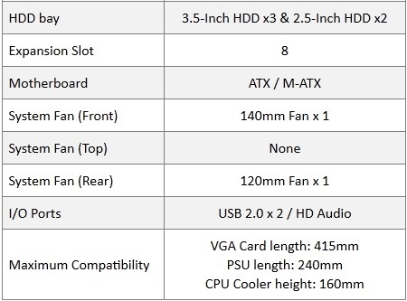
For more on the Lancool PC-K56N:
http://www.lancoolpc.com/en/product/product06.php?pr_index=52&cl_index=1&sc_index=25&ss_index=62&g=f
Lancool PC-K56N Youtube Video:
http://www.youtube.com/watch?feature=player_embedded&v=SMIpxsUEYUE

About Lancool
The Lancool brand is owned by Lian-Li Industrial Co. Ltd. With over 20 years of service excellence, ISO 9001 certification and a team of professional staff willing to do the utmost to deliver durable, superior quality products, the Lancool brand caters to the mainstream gamer and enthusiast in the mid- to high-end market segment. The Hybrid Aluminum and Steel Chassis provide unique and definitive solutions for the discerning needs of enthusiast-level gamers. For more information, please visit the Lancool website: www.LancoolPC.com

